Understanding Theme Name_____________________
Using Details and Main Ideas Date______________________
Class______________________
Study the main ideas from our novels, Trophies, or Storyworks. Then use the information to determine the message that the author of each selection has for us. Here are some common themes found in literature.

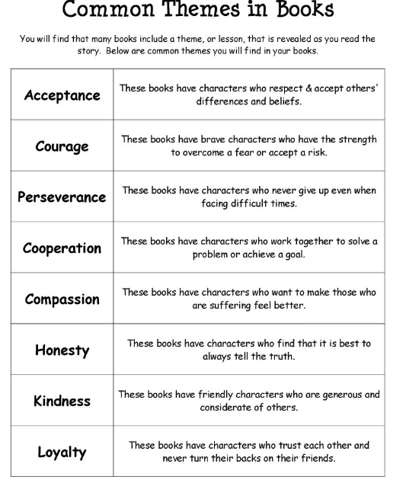

http://www.scholastic.com/teachers/top_teaching/2011/02/helping-students-grasp-themes-in-literature

Common Theme Conflicts

These three conflicts are found in many pieces of literature and describe human struggles.

Person vs. Self fighting within oneself to grow or resolve
issue
Person vs. Nature working to survive something from nature
Person vs Society fighting against a problem in society

With Love from Ella, Letters from Barbara Jordan, Pirate Hero
- Ella Fitzgerald had many obstacles in her life, but always worked for others and followed her dream.
- Barbara Jordan spent her career in Congress and as a teacher, working for others even when she was ill.
- Roberto Clemente worked hard for his baseball team and also worked to help others. He even gave his life while bringing supplies to people in need.

- What do these stories have in common?
___________________________________________________________________________
- Which conflict does this address? Why have you made this choice?
_______________ - __________________________________________________________
- What theme does this address? Why have you made this choice?
_________________ - ________________________________________________________
___________________________________________________________________________

The Courage of Sarah Noble, The Sign of the Beaver
- Sarah travels to the Connecticut wilderness where her family will have a new home. She must “keep up her courage” while staying in this unfamiliar land and (later) with a new family.
- Matt travels his father to the wilderness of Maine where his family has a claim. Later, he must stay at the new homestead on his own and his helped by a slowly growing friendship with the nearby Penobscot Indians.

1. What do these stories have in common?
___________________________________________________________________________
2. Which conflict does this address? Why have you made this choice?
_______________ - __________________________________________________________
- What theme does this address? Why have you made this choice?
_________________ - ________________________________________________________
___________________________________________________________________________

Mountain of Fire, Krakatoa Wave, Flowers after the Flames
- A volcano erupts after being silent for many years. People had ignored signs of trouble at first and didn’t see refuge at first. They have now gained new respect for the power of nature and will rebuild more carefully.
- A volcano erupts in a massive explosion, causing earthquakes and tsunamis. Thousands die and much property is destroyed. People will not forget this example of the power of nature.
- After a very dry spring and summer, a massive forest fire erupts in a large national park. The park service follows a failed policy and does not try to stop the fire at first. When the fire gets too big, officials have to wait for nature (in the form of rain and snow) to put the fire out. Half the park is damaged, but nature helps it to rebuild with a different kind of beauty.

1. What do these stories have in common?
___________________________________________________________________________
2. Which conflict does this address? Why have you made this choice?
_______________ - __________________________________________________________
3. What theme does this address? Why have you made this choice?
_________________ - ________________________________________________________
___________________________________________________________________________

